Week 7 Course Project:

User Manual

Anthony Meunier

DeVry University

CIS 355A

Customer Tab

In the first tab of the application, the user is presented with text fields that allow the input of customer information. As you can see here, general information such as Customer Name and Customer Address is collected so it can be stored for order purposes/information, as well as be stored into the database. From the user’s perspective, all that needs to be done is simply to type the desired information into the text fields and the information is temporarily stored within the application until the order is either completed or terminated.

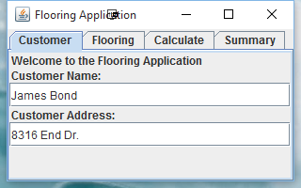

Conversely, if no information is entered into these fields and the order is attempted to be submitted, there will be the following error message displayed to inform the user of the error:

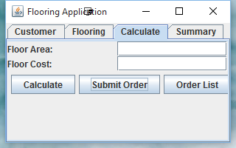

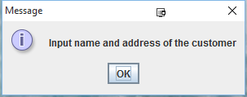

Flooring Tab

The flooring tab is used to input the length and width of the desired floor to be installed. In addition, the user can also select between two options for which type of flooring will be installed – wood ($20 per square foot) or carpet ($10 per square foot). The application stores this information and selection and will later on use it to calculate the cost of the flooring.

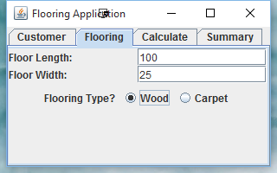

Again, if the user does not enter valid numeric values or if the fields for floor length and/or floor width are left blank then the following error message will be displayed to alert the user:

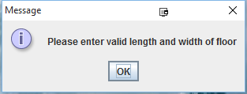

If the flooring type is not selected then the following error message will alert the user:

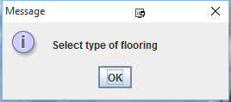

Calculate Tab

The calculate tab is where all the information is finally tied together to 1) calculate and display the total area and total cost when the calculate button is pressed (based on the information entered so far in the application), 2) submit the order, which saves the information to the database when the button is pressed, and 3) display a list of the orders and their summary (pulled from database).

The Calculate button validates information entered thus far and displays totals:

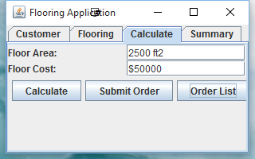

The Submit Order button adds the order to the database and essentially makes the information entered finalized:

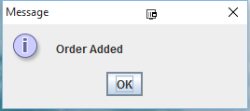

The Order List button displays a summary of the database and its orders and their respective information that have been submitted this far:

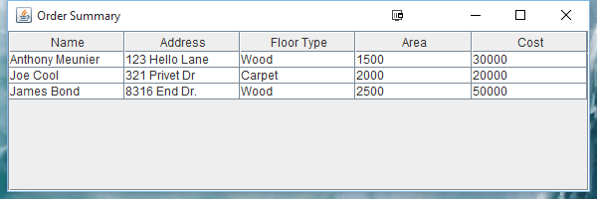

Summary Tab

The Summary tab is similar to the previous calculate tab and its “Order List” function in that it displays the results of the order, but the key difference is the Summary tab only shows information pertaining to the order the user just entered – not the whole database of orders:

